Protect Your Pets From
FLEAS & TICKS!
Use the products we know and trust for our own pets!
Apply topical products monthly, year-round for best protection!

For all topical products, do not bathe pet or allow pet to
swim 24 hours before or after applying product.

Dogs:
- Parastar Plus for Dogs (fipronil,cyphenothrin)
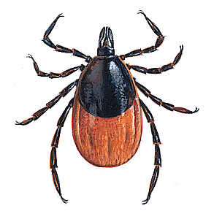
  - Provides the fastest tick kill, starts to kills ticks in as little as 1 hour.
  - Two active ingredients for fast-acting, long-lasting control of ticks, fleas and chewing lice.
    - Provides significantly superior speed of tick kill for a whole month, compared to Frontline Plus.*
    - Outlasts Frontline Plus, effectively killing ticks all month long.*
  - For use on dogs and puppies 12 weeks of age & older. NOT for use on cats!
  - When using this on your dogs, keep separate from cats for 12-24 hours after applying. This will allow time for product to dry.

- Parastar for Dogs (fipronil)
  - Kills fleas & ticks, including those that may transmit Lyme disease, chewing lice and mites that may cause sarcoptic mange.
  - Fast-acting. Long-lasting. Waterproof.
  - Same active ingredient as Frontline Plus.
  - For use on dogs and puppies 8 weeks of age & older. NOT for use on cats.

Cats:
- Easy Spot for Cats (fipronil)
  - Kills fleas, flea eggs and flea larvae & prevents all flea stages (eggs, larvae, pupae) from developing.
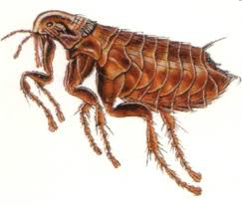
  - Kills all life stages of ticks (larva, nymph and adult).
  - Rapidly eliminates chewing lice infestations.
  - For use on cats and kittens 8 weeks of age & older.

- Revolution (selamectin)
  - Kills adult fleas and prevents flea eggs from hatching.
  - Treats and controls ear mite (Otodectes cyanotis) infestations.
  - Prevents heartworm disease caused by Dirofilaria immitis.
  - Treats and controls intestinal hookworm & roundworm infections.
  - For use on cats and kittens 8 weeks of age & older.

